Storyboard - Special card

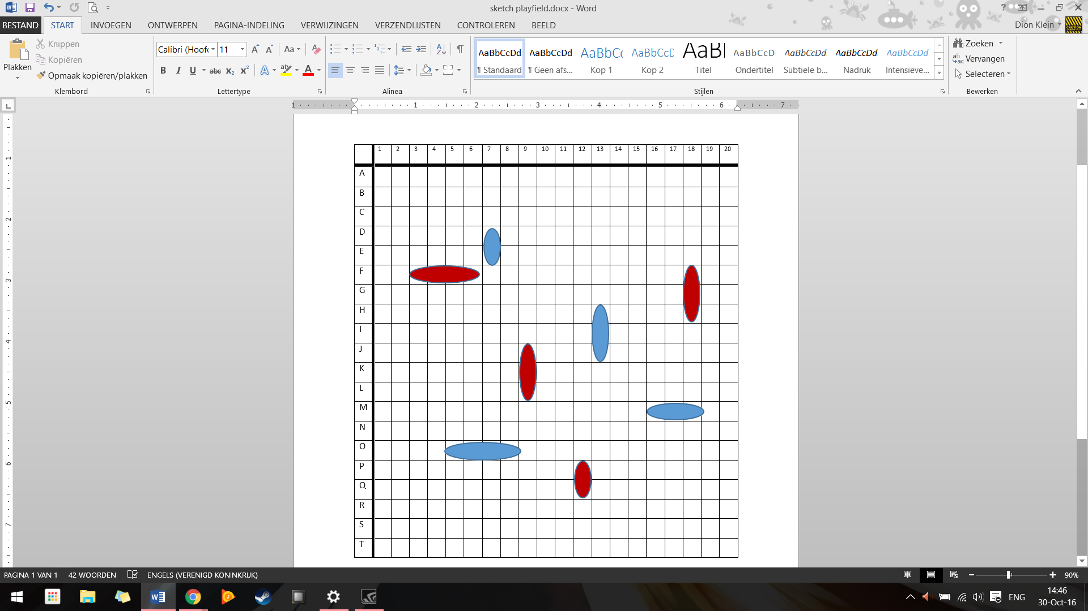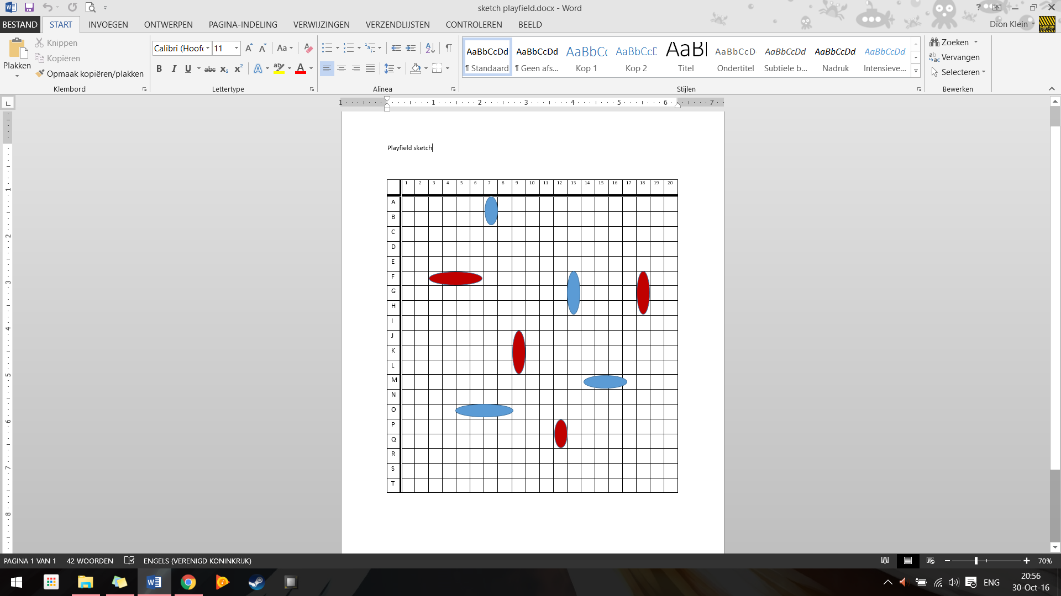

in picture 1, Blue has a clear path towards the opponent’s baseline. During his next move he will move his small ship and collect the special card. Let's say the collected card grants this ship double movement for rest of the game. The ship is now able to move six steps instead of the regular three for this kind of ship. Using his new ability, the small ship can quickly reinforce its comrades.

However, during these actions, Red has also collected a special card. 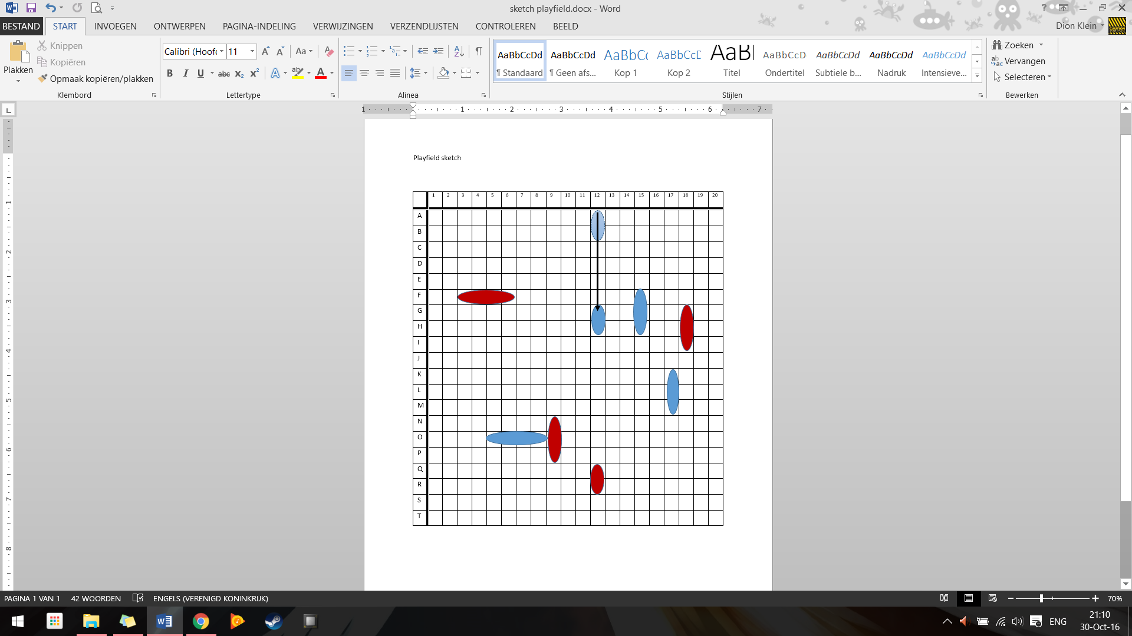

Don’t forget about your defense!